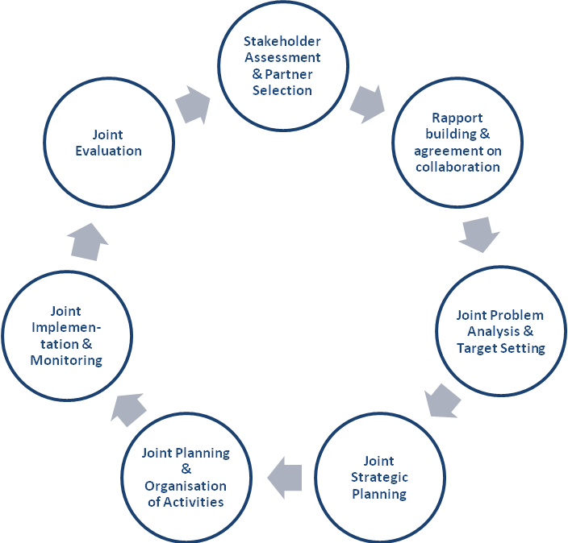

Systematic diagram of an integrated action planning process

